Assignment 2

**create 'product_db' database:**

**CREATE DATABASE product_db;**

**Use database:**

**USE product_db;**

**create following tables categories:**

**id (PK), title, description**

create table categories(

    id int PRIMARY KEY identity (1,1),

    title varchar(20),

    description varchar(50)

);

**products: id (PK), title, price, description, category (FK), company**

create table products (

    id int PRIMARY KEY identity (1,1),

    title varchar(20),

    price bigint,

    description varchar(30),

    category INT,

    company varchar(30)

    FOREIGN key (category) REFERENCES categories(id)

**orders: id (PK), total, date**

create table orders (

    id int PRIMARY KEY identity (1,1),

    total int,

    date date

);

**order_details: id (PK), orderId (FK), productId (FK), quantity, price, totalPrice, discount**

create table order_details(

    id int PRIMARY KEY identity (1,1),

    orderId int,

    productId int,

    quantity varchar(30),

    price INT,

    totalPrice varchar(30),

    discount int

    FOREIGN key (orderId) REFERENCES orders(id),

    FOREIGN key (productId) REFERENCES products(id)

);

**Insert data:**

insert into categories(

    title,

   description

)

values (

'mobile', 'smart phone with new tech.'),

('laptop','smart laptop with new tech.'),

 ('tv', 'smart tv with new tech.'),

 ('camera', 'smart camera with new tech.'),

 ( 'tablet', 'smart tablet with new tech.'),

 ( 'accessories', 'smart accessories with new tech.'

);

insert into products(

    title,

    price,

    description,

    category,

    company

)

values(

    'mi note 9',15000,'4gb ram 256gb storage',1,'Redmi'),

('thinkpad',50000,'8gb ram 1tb storage',2,'Lenovo'),

('lg smart tv',32000,'4K dolby vision',3,'LG'),

('w800',27000,'20.1 mp digital camera',4,'Sony'),

('galaxy tab S',40000,'6gb ram 256gb storage',5,'Samsung'),

('Boat rockerz',5000,'wireless earphone',6,'Boat');

insert into orders (

    total,

    date

)

VALUES (

    10000,'2022-08-25'),

    (12000,'2022-08-26'),

    (15000,'2022-08-27'),

    (9000,'2022-08-28'),

    (20000,'2022-08-29'),

    (30000,'2022-08-22');

insert into order_details(

    orderId,

    productId,

    quantity,

    price,

    totalPrice,

    discount

)

VALUES(

    2,1,20,15000,100000,20

),

(3,2,20,15000,100000,20),

(4,3,10,50000,400000,20),

(5,4,30,32000,500000,20),

(6,5,22,27000,600000,20),

(7,6,32,5000,100000,20);

**Select * from categories;**

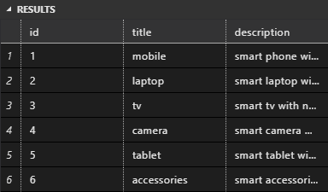

**Select * from products;**

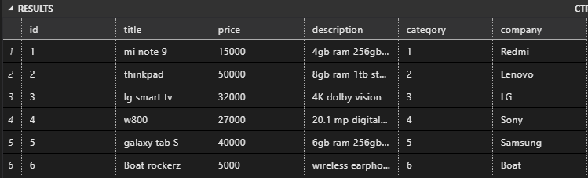

**Select * from orders;**

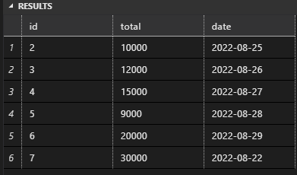

**Select * from order_details;**

